DAYANANDA SAGAR UNIVERSITY

**DEPARTMENT OF COMPUTER SCIENCE & ENGINEERING SCHOOL OF ENGINEERING**

**DAYANANDA SAGAR UNIVERSITY KUDLU GATE, BANGALORE –560068**



### PROJECT REPORT

**ON**

## “Emotion Recognition based on EEG using Deep Learning”

**2023**

**BACHELOR OF TECHNOLOGY**

***IN***

**COMPUTER SCIENCE & ENGINEERING** **(DATA SCIENCE)**

***Submitted by***

**ABHISHEK A - ENG21DS0002** **ABHISHEK N - ENG21DS0003** **NIKUNJ VIHARI – ENG21DS0023 ESHWAR REDDY M – ENG21DS0053**

**Under The Supervision of:**

**Dr. SHAILA S G**

### CHAIRPERSON , DATA SCIENCE

DAYANANDA SAGAR UNIVERSITY

**DEPARTMENT OF COMPUTER SCIENCE & ENGINEERING SCHOOL OF ENGINEERING**

**DAYANANDA SAGAR UNIVERSITY KUDLU GATE, BANGALORE –560068**



***CERTIFICATE***

It is certified that the SPECIAL TOPICS project work entitled “***EMOTION RECOGNITION BASED ON EEG USING DEEP LEARNING”*** has been carried out at ***Dayananda Sagar University, Bangalore***, by ABHISHEK A(ENG21DS0002)***,*** ABHISHEK N(ENG21DS0003)***,*** NIKUNJ VIHARI (ENG22DS0023), ESHWAR REDDY M(ENG21DS0053)***,*** bonafide students of ***fifth Semester, B.tech.***in partial fulfilment for the award of degree in ***Bachelor of Technology*** in ***Computer Science& Engineering, Data Science*** during academic year ***2023-24.*** It is attested that the report has been updated with all modifications and suggestions designated for internal assessment.

Signature of the Guide Signature of the HOD

## ACKNOWLEDGEMENT

Although a project's completion offers a sense of satisfaction, it is never done without acknowledging everyone who contributed to its accomplishment.. We wish to express our profound feelings of gratitude to this great institution of ours DAYANANDA SAGAR UNIVERSITY for providing the excellent facilities.

We are especially thankful to our Chairperson, **Dr. Shaila S G**, for providing necessary departmental facilities, moral support and encouragement. The largest measure of our acknowledgment is reserved for Dr. Shaila S G whose guidance and support made it possible to complete the project work in a timely manner.

We have received a great deal of guidance and co-operation from the staff and we wish to thank all that have directly or indirectly helped us in the successful completion of this project work.

ABHISHEK A - (ENG21DS0002) ABHISHEK N - (ENG21DS0003)

NIKUNJ VIHARI - (ENG21DS0023)

ESHWAR REDDY M- (ENG21DS0053)

## DECLARATION

We hereby declare that the Special Topics project entitled “EMOTION RECOGNITION BASED ON EEG USING DEEP LEARNING” submitted to Dayananda Sagar University, Bengaluru, is a bonafide record of the work carried out by us under the guidance of Dr. SHAILA S G,CHAIRPERSON, (DATA SCIENCE) School of Engineering, Dayananda Sagar University, and this work is submitted for the completion of the special topics-2 in 5th semester under Bachelor of Technology in Computer Science and Engineering (data science).

ABHISHEK A - (ENG21DS0002) ABHISHEK N - (ENG21DS0003)

NIKUNJ VIHARI - (ENG21DS0023)

ESHWAR REDDY M- (ENG21DS0053)

# TABLE OF CONTENTS

|  |  |
| --- | --- |
| **CHAPTERS** | **PAGE NO** |
| **1. INTRODUCTION** | **1-2** |
| **2. LITERATURE REVIEW** | **3-4** |
| **3. OBJECTIVES AND SCOPE OF WORK**    **4. DESCRIPTION OF WORK**  **4.1 DATASET DESCRIPTION**  **4.2 DATA PREPROCESSING**  **5. PROPOSED METHODOLOGY**  **6. CODE SNIPPETS , RESULTS & OUTPUTS**  **7. FUTURE SCOPE**  **8.CONCLSUION** | **5**  **6-11**  **6-8**  **9- 11**  **12-14**  **15- 17**  **18**  **19** |
| **9. REFERENCES** | **20** |
|  |  |
|  |  |

**ABSTRACT**

This project explores the realm of emotion recognition through the analysis of electroencephalogram (EEG) signals employing advanced deep learning techniques. Emotions play a pivotal role in human communication and understanding, and capturing them through physiological signals offers a nuanced perspective. The project leverages a dataset of EEG signals obtained during various emotional states to train a deep learning model. The model, constructed using state-of-the-art neural network architectures, is adept at extracting intricate patterns from the EEG data.

The process involves preprocessing raw EEG signals, feature extraction, and subsequent classification into distinct emotional categories. The achieved results underscore the efficacy of the proposed methodology, demonstrating a high accuracy in emotion classification. The significance of this work lies in its potential applications, ranging from mental health monitoring to human-computer interaction systems that respond to users' emotional states. As technology continues to intertwine with human experiences, the ability to decipher emotions through EEG signals opens new avenues for personalized and adaptive systems. This project contributes to the growing field of affective computing, showcasing the feasibility and effectiveness of deep learning in decoding emotional states from EEG signals.

## INTRODUCTION

## Image

## In the contemporary landscape of human-computer interaction and affective computing, understanding and interpreting human emotions have emerged as critical elements for creating intelligent and responsive systems. Emotions are intrinsic to the human experience, influencing decision-making, communication, and overall well-being. As technology becomes more integrated into our daily lives, the ability to recognize and respond to human emotions becomes paramount. This project delves into the realm of emotion recognition with a focus on utilizing electroencephalogram (EEG) signals and harnessing the power of deep learning techniques.

## The field of affective computing seeks to imbue machines with the ability to comprehend and respond to human emotions, thereby fostering a more natural and intuitive interaction. Traditional methods of emotion recognition often rely on facial expressions, speech patterns, or physiological signals such as heart rate. However, the brain, as the epicenter of emotional processing, offers a unique and rich source of information. EEG signals, which measure electrical activity in the brain, provide a direct window into the neural correlates of emotions.

## The primary objective of this project is to develop a robust emotion recognition system that relies on EEG signals as input data. EEG signals offer a real-time and non-invasive means of capturing brain activity, making them particularly suitable for dynamic emotional states. Leveraging the advancements in deep learning, specifically neural network architectures, enables the creation of models capable of learning intricate patterns within EEG data, contributing to more accurate and nuanced emotion classification.

## The project utilizes a carefully curated dataset comprising EEG recordings obtained during various emotional stimuli. Subjects participating in a study were exposed to stimuli designed to elicit specific emotional responses, ranging from joy and sadness to anger and surprise. This diverse dataset forms the foundation for training and evaluating the deep learning model.

## 

## 

## Image

## The workflow of the project involves several key stages. Initially, raw EEG signals undergo preprocessing to remove artifacts and enhance the quality of the data. Feature extraction follows, where relevant information is distilled from the preprocessed signals to serve as input features for the deep learning model. The core of the project lies in the design and training of the deep learning model, employing architectures such as convolutional neural networks (CNNs) or recurrent neural networks (RNNs), tailored to capture the temporal and spatial intricacies of EEG data.

## Emphasis is placed on achieving not only high accuracy in emotion classification but also on the interpretability of the model. Understanding the features and patterns that contribute to emotional states is crucial for both the validation of the model and the potential integration into practical applications.

## The significance of this project extends beyond the realm of academic exploration. Applications include mental health monitoring, where real-time emotion recognition could provide insights into an individual's emotional well-being. Additionally, adaptive human-computer interaction systems could utilize this technology to respond dynamically to users' emotional states, enhancing user experience and engagement.

## As we delve into this intersection of neuroscience, artificial intelligence, and human-computer interaction, the project represents a step forward in unraveling the complexities of human emotions. The synergy of EEG signals and deep learning techniques offers a promising avenue for the development of intelligent systems that can comprehend and respond to the subtle nuances of human emotional expression. This introduction sets the stage for an in-depth exploration of the methodology, results, and implications of the project, contributing to the evolving landscape of affective computing.

1. **LITERATURE REVIEW**

|  |  |  |  |
| --- | --- | --- | --- |
| **Paper Title** | **Authors** | **Published in** | **Summary** |
| "DEAP: A Database for Emotion Analysis using Physiological Signals" | S. Koelstra, C. Muehl, M. Soleymani, J.-S. Lee, A. Yazdani,  T. Ebrahimi,  T. Pun,  A. Nijholt,  I. Patras | IEEE Transactions on Affective Computing, 2012 | Introduces the DEAP dataset for emotion analysis, focusing on dataset creation with self-assessment ratings and physiological signals. |
| "Emotion Recognition In The Wild Challenge 2014: Baseline, Data and Protocol" | Abhinav Dhall,  Roland Goecke,  Jyoti Joshi,  Karan | Proceedings of 16th International Conference on Multimodal Interaction | Addresses the Emotion Recognition in the Wild Challenge 2014, proposing a neural network-based model with modality-specific networks trained on audio and video data. Achieves 37.84% accuracy, outperforming the baseline. |
| "Emotion Recognition from Physiological Signal Analysis: A Review" | Maria Egger,  Matthias Ley,  Sten Hanke | ScienceDirect, 2019 | Explores emotion recognition methods in human-computer interaction, comparing facial analysis, smart wearables, and multimodal systems. Highlights EEG achieving 88.86% accuracy. |
| "Locally robust EEG feature selection for individual-independent emotion recognition" | Zhong Yin,  M. Lei Liu,  Box Zhao,  Yongxiong Wang, Jianing Chen | ScienceDirect, 2020 | Addresses individual differences in emotion recognition in BCI systems, introduces Locally-Robust Feature Selection (LRFS) method, achieves competitive classification accuracy using ensemble learning. |
| **Paper Title** | **Authors** | **Published in** | **Summary** |
| "Single Trial EEG Classification Applied To a Face Recognition Experiment Using Different Feature Extraction Methods" | Yudu Li,  Sen Ma,  Zhongze Hu,  Jiansheng Chen | IEEE Transactions on Pattern Analysis and Machine Intelligence | Compares feature extraction methods in EEG-based classification for face recognition. Principal component analysis achieves 94.2% accuracy. |
|  | M. Prakash,  Dr. K Sankar,  Dr. R N Muhammad Ilyas | International Journal of Engineering Research & Technology, 2021 | Addresses real-time expression recognition in physically challenged individuals and children with disorders using CNN and LSTM classifiers. Achieves high recognition rates for facial expressions (99.25%) and emotions from EEG signals (87.96%). |
|  |  |  |  |

## OBJECTIVES AND SCOPE OF WORK

The primary objectives of this project are to develop an effective emotion recognition system based on EEG signals, employing advanced deep learning techniques. The specific goals include preprocessing raw EEG data, extracting relevant features, and training a deep learning model for accurate emotion classification. The project aims to explore diverse emotional states, encompassing joy, sadness, anger, surprise, and more, using a carefully curated dataset

.

The scope of work spans the entire pipeline of emotion recognition, from data collection and preprocessing to model training and evaluation. The project focuses on leveraging the temporal and spatial information embedded in EEG signals to enhance the model's accuracy and interpretability. The outcomes are expected to contribute not only to the academic understanding of emotion recognition but also to practical applications in mental health monitoring and adaptive human-computer interaction systems. The project's significance lies in its potential to advance the integration of neuroscience and deep learning for a more nuanced understanding of human emotions.

## DESCRIPTION OF WORK

## DATASET DESCRIPTION

## [DEAP Dataset](https://www.eecs.qmul.ac.uk/mmv/datasets/deap/)

## Dataset:

## 

## No of files : 32

## Each file contains :

## 40 x 40 x 8064

## (video/trial x channels x data)

## (Numpy ndarray format)

## Classes : 40 videos, each associated with single emotion class.

## Features : 13 most contributing of 40 channels recording EEG and Physiological data.

## Time-series component : channel data recorded across time instances.

## Recordings : 32 persons were shown 40, 60s videos while being recorded using EEG.

The meticulously curated DEAP (Database for Emotion Analysis using Physiological Signals) dataset, prepared by Queen Mary University of London, serves as a comprehensive resource for exploring emotion recognition through physiological signals. This dataset seamlessly integrates self-assessment ratings obtained via online evaluations with physiological recordings from an experimental setup, offering a nuanced understanding of emotional responses.

Online Self-Assessment**:**

1. Online Ratings:
   * Volunteers engaged in an online self-assessment, evaluating 120 one-minute music video extracts.
   * Arousing, valence, and dominance dimensions were rated on a discrete 9-point scale, capturing subjective emotional experiences.
   * Supplementary ratings involved the use of an emotion wheel, providing additional depth to emotional characterization.
2. Video List**:**
   * The 'online_ratings' file, available in various spreadsheet formats, contains individual ratings linked to specific videos through Online_id.
   * The 'video_list' file, also in spreadsheet formats, details the music videos used in both the online self-assessment and the subsequent experiment. It includes artist information, titles, YouTube links, and statistical summaries.

* Experimental Setup**:**

1. Participant Ratings:
   * In the experimental phase, 32 participants engaged with a subset of 40 music videos, providing ratings for valence, arousal, dominance, liking, and familiarity.
   * Ratings were collected using SAM mannequins and continuous 9-point scales, offering a fine-grained analysis of emotional responses.
2. Participant Questionnaire:
   * The 'participant_questionnaire' file includes responses from participants to pre-experiment questionnaires, shedding light on participant demographics and consent details.
3. Face Video**:**
   * 'Face_video.zip' encompasses frontal face videos recorded for the first 22 participants, segmented into trials.
   * Technical considerations resulted in the absence of specific trials for participants 3, 5, 11, and 14.
4. Physiological Data**:**
   * 'Data_original.zip' presents the original unprocessed physiological data recorded in BioSemi .bdf format, with distinct channel orders and GSR measurement units for participants recorded in Twente and Geneva.

Data Preprocessing and Analysis**:**

1. Preprocessed Data**:**
   * 'Data_preprocessed_matlab.zip' and 'data_preprocessed_python.zip' provide downsampled (128Hz), preprocessed, and segmented data in MATLAB and Python formats.
   * Each participant file encapsulates data and labels for valence, arousal, dominance, and liking, organized to facilitate straightforward analysis.
2. Channel Layout**:**
   * EEG channels underwent meticulous preprocessing, involving downsampling, artifact removal, filtering, and segmentation.
   * The order and preprocessing nuances for EEG, EOG, EMG, and other channels are thoughtfully detailed, ensuring methodological consistency.

* ETHICAL CONSIDERATION OF THE DATASET:

Ethical considerations played a pivotal role in this project, particularly regarding the use of the DEAP dataset. To access this valuable resource, we adhered to ethical standards by obtaining the necessary licenses. A commitment was made to utilize the dataset solely for study and research purposes, aligning with ethical guidelines and legal obligations. This assurance reflects our dedication to maintaining the privacy and rights of the individuals involved in the dataset, reinforcing ethical responsibility in handling sensitive EEG data. Respecting licensing agreements underscores our commitment to ethical research practices, ensuring transparency and integrity throughout the project lifecycle.

4.2. DATA PREPROCESSING

Data pre-processing is a pivotal stage in this project, aimed at refining the raw EEG signals to ensure the quality and reliability of the dataset. Raw EEG data inherently contain noise, artifacts, and irregularities that can impede accurate analysis. To mitigate these challenges, sophisticated signal processing techniques are applied. Signal filtering is employed to remove unwanted noise, enhancing the signal-to-noise ratio and preserving relevant neural activity. Additionally, artifact rejection methods are utilized to identify and eliminate anomalies, such as eye blinks or muscle artifacts, ensuring that the subsequent analysis is based on authentic neural patterns.

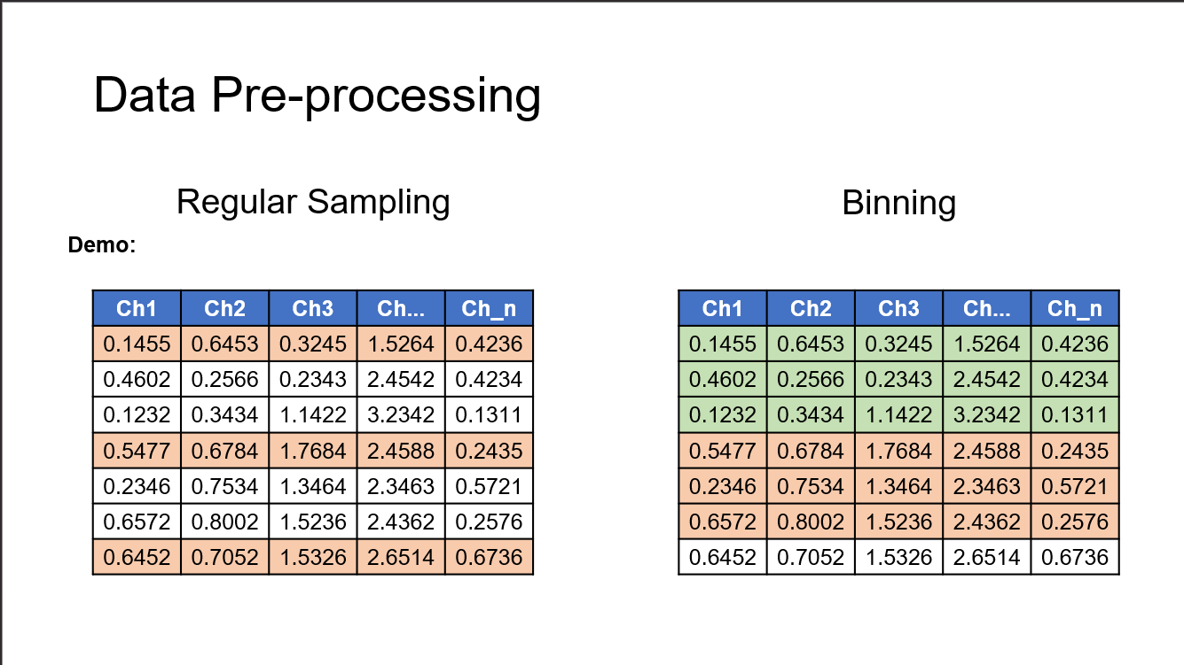

Data pre-processing is a pivotal stage in this project, aimed at refining the raw EEG signals to ensure the quality and reliability of the dataset. Raw EEG data inherently contain noise, artifacts, and irregularities that can impede accurate analysis. To mitigate these challenges, sophisticated signal processing techniques are applied. Signal filtering is employed to remove unwanted noise, enhancing the signal-to-noise ratio and preserving relevant neural activity. Additionally, artifact rejection methods are utilized to identify and eliminate anomalies, such as eye blinks or muscle artifacts, ensuring that the subsequent analysis is based on authentic neural patterns.

Furthermore, regular sampling is implemented to harmonize the EEG signals by establishing a consistent sampling rate. This step is crucial for maintaining temporal uniformity, facilitating subsequent feature extraction processes. By adhering to a standardized sampling rate, irregularities in signal timing are minimized, enabling a more reliable representation of the temporal dynamics of the neural activity.

Overall, data pre-processing acts as a foundational step, enhancing the quality of the EEG dataset and laying the groundwork for subsequent stages, including feature extraction and model training. The refined dataset serves as the basis for constructing a robust emotion recognition system, ensuring that the subsequent deep learning model can effectively learn and extract meaningful patterns from the EEG signal.

* DIFFERENT DATA PREPROCESSING TECHNIQUES USED
* Regular Sampling:

Regular sampling is a crucial aspect of data preparation in this project, ensuring a consistent and uniform temporal structure for EEG signals. By enforcing a standardized sampling rate across the dataset, irregularities in signal timing are minimized

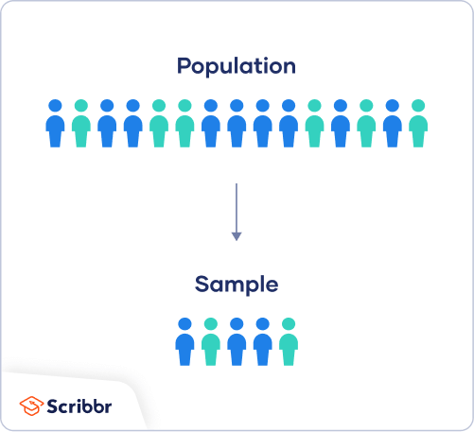

This harmonization is essential for subsequent stages, such as feature extraction and model training, as it facilitates a more accurate representation of the temporal dynamics of neural activity. Regular sampling contributes to the overall reliability of the dataset, enabling the subsequent deep learning model to effectively capture and analyze temporal patterns associated with various emotional states.

* Binning:

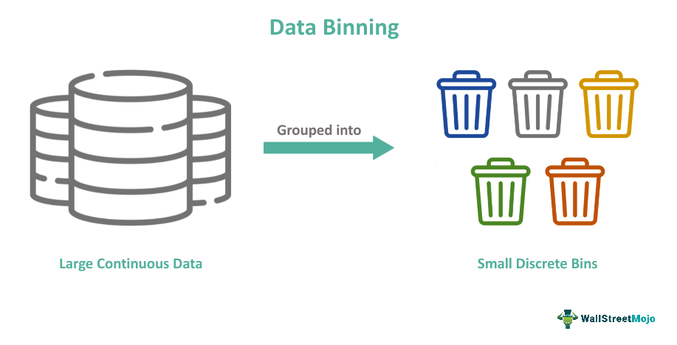

In the context of this project, binning is a vital preprocessing step involving the categorization of EEG signals based on temporal or spectral characteristics. This segmentation facilitates a targeted approach to capturing specific patterns associated with different emotional states. By organizing the EEG data into discrete bins, the subsequent feature extraction process becomes more focused, enabling the deep learning model to discern nuanced nuances in emotional responses. Binning serves as a strategic method to enhance the relevance and specificity of the data, contributing to the overall effectiveness of the model in accurately classifying diverse emotional states.

* Flattening:

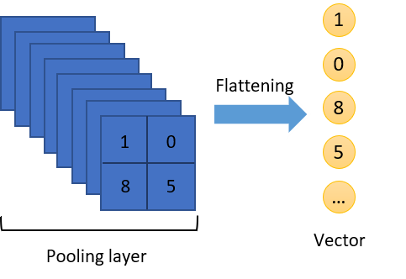

Flattening is a pivotal preprocessing step, transforming multi-dimensional EEG data into a one-dimensional format for efficient integration into the deep learning model. This process simplifies the input structure, optimizing information flow through the neural network's layers. By converting the complex data representation into a flattened format, computational efficiency is enhanced, ensuring streamlined processing. The flattened representation retains essential features while simplifying the neural network's computational load. This preprocessing technique not only improves the model's efficiency but also maintains the integrity of critical information, facilitating effective analysis and accurate classification of emotional states based on EEG signals.

1. **PROPOSED METHODOLGY**

* Why the Choice of EEG:

The selection of EEG as a primary criterion in this project stems from its unique ability to directly capture neural activity associated with emotional states. EEG offers a non-invasive and real-time approach, providing a nuanced insight into the temporal dynamics of brain function. Its high temporal resolution makes it well-

suited for tracking rapid changes in emotional responses. By leveraging EEG signals, the project aims to decipher the intricate neural patterns indicative of various emotions.

This choice aligns with the project's goal of creating a robust emotion recognition system, capitalizing on the rich information embedded in EEG data for a more comprehensive

understanding of human emotional experiences.

The proposed methodology for this project is anchored in the development of a novel deep learning model tailored for emotion recognition based on EEG signals. This forward-looking approach combines various techniques to enhance the model's accuracy and interpretability.

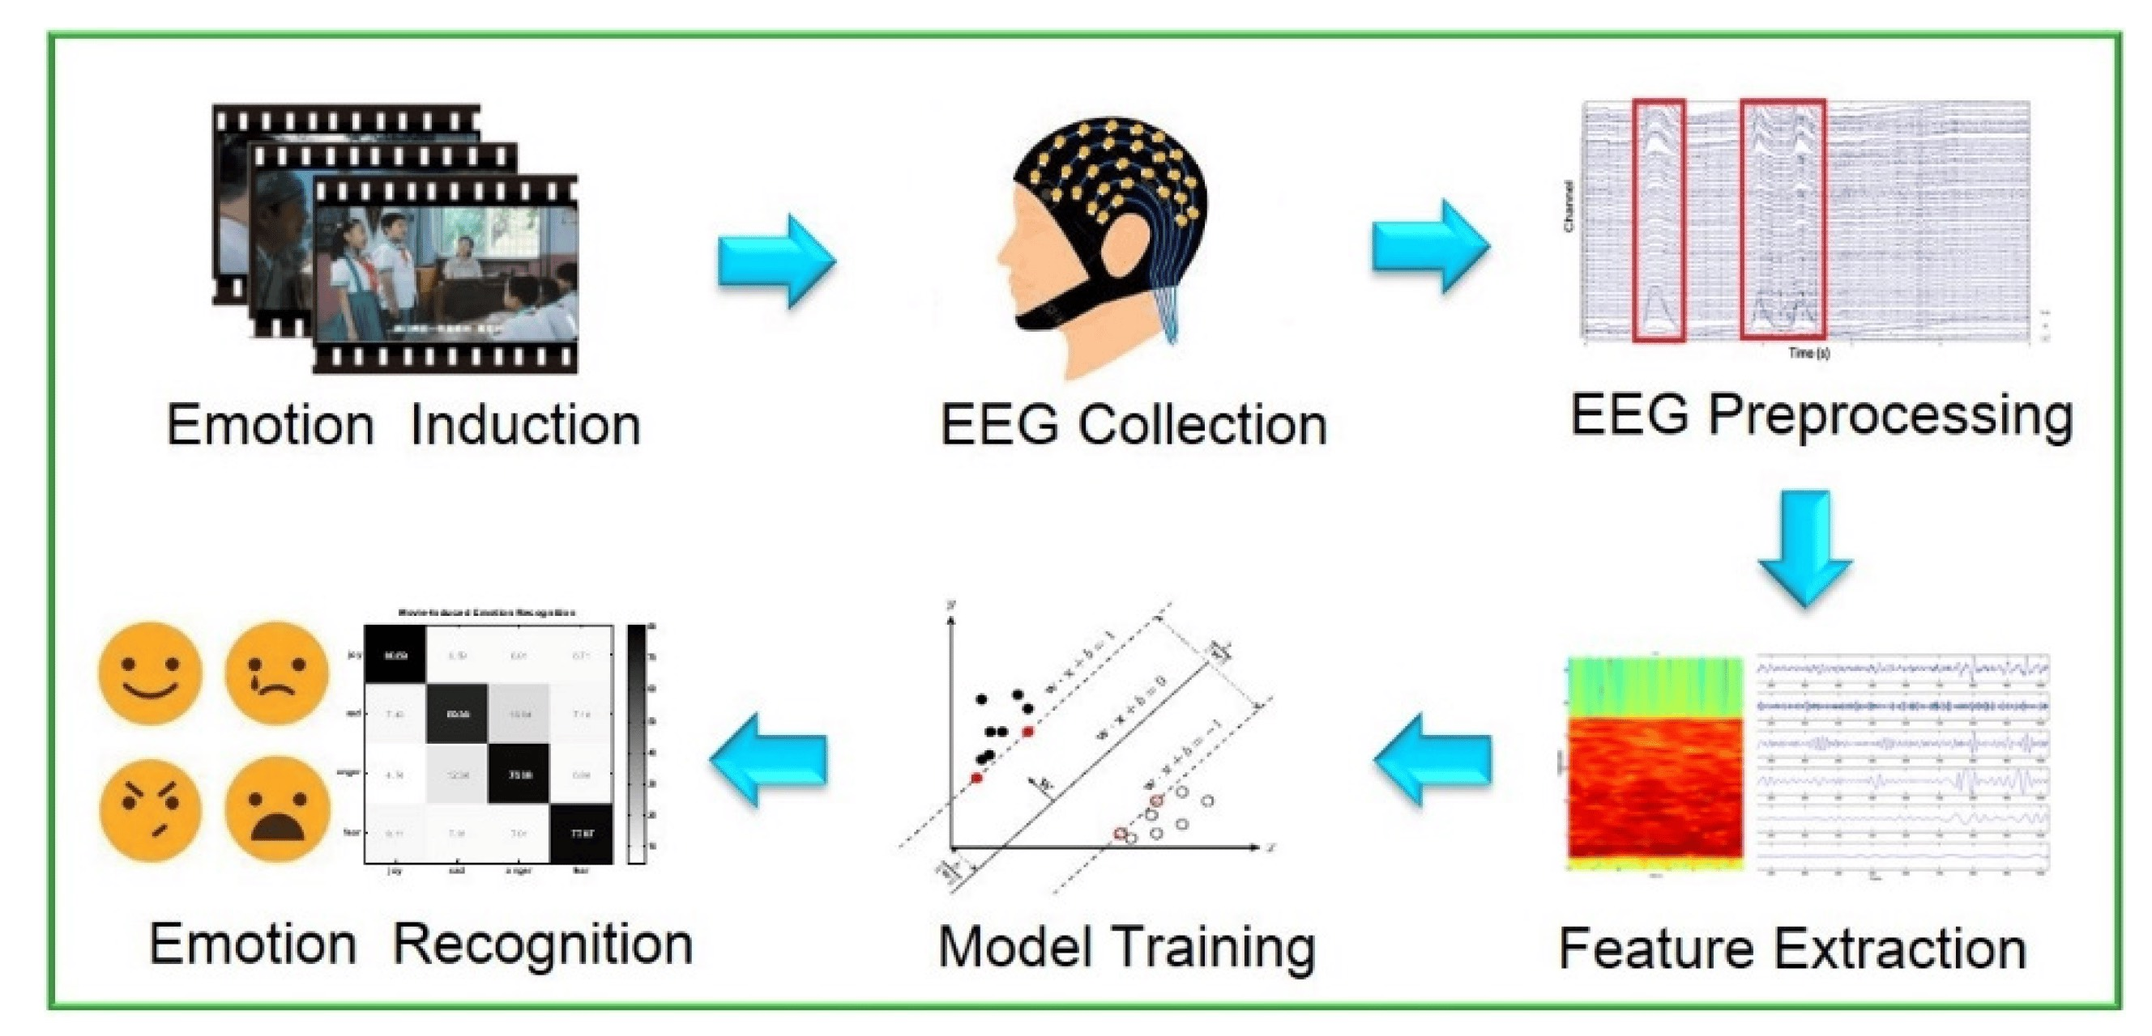

* Proposed Deep Learning Model**:**

At the core of the methodology is the introduction of a novel deep learning model architecture. Autoencoder models are strategically employed to decompose the original EEG data into key signal components. This process enhances the model's ability to capture intricate patterns within the data by focusing on essential features.

Moreover, the methodology incorporates the extraction of Power Spectral Density (PSD) features. This spectral analysis provides insights into the distribution of signal power across different frequencies, offering a robust representation of the EEG data's frequency-domain characteristics. The inclusion of PSD features enriches the model with relevant information for more effective emotion classification.

To capture the temporal relationships within the extracted PSD features, Long Short-Term Memory (LSTM) recurrent neural networks are introduced. LSTMs excel in capturing sequential dependencies, making them ideal for modeling the dynamic nature of EEG signals over time. By leveraging LSTM networks, the proposed model aims to discern subtle variations in the temporal patterns of PSD features associated with different emotional states.

* Model Optimization**:**

The research methodology includes a rigorous phase of model optimization. Numerous comparison experiments are conducted to identify the optimal model structure and hyperparameters. This iterative process involves fine-tuning the architecture and parameters based on performance metrics, ensuring the model's robustness and adaptability to diverse emotional contexts.

Through systematic experimentation, the methodology aims to strike a balance between model complexity and generalization capabilities. This optimization phase is essential for achieving a well-performing deep learning model that can accurately classify emotions in real-world scenarios.

* Utilization of MNE:

To enhance the understanding, visualization, and analysis of human EEG data, the research incorporates the utilization of the open-source Python package, MNE (MNE-Python). MNE-Python provides a comprehensive set of tools for processing and analyzing EEG data. Its capabilities include preprocessing, visualization, and feature extraction, aligning with the project's goals.

The MNE package facilitates a deeper exploration of EEG data, allowing researchers to visualize spatiotemporal patterns, identify potential artifacts, and gain insights into the characteristics of different emotional responses. By integrating MNE into the methodology, the research process benefits from an enriched toolkit for handling EEG data, fostering a more comprehensive and nuanced understanding of the underlying neural dynamics associated with emotions.

In conclusion, the proposed methodology not only introduces a novel deep learning model architecture but also emphasizes a meticulous approach to model optimization and leverages the power of MNE for a holistic exploration of EEG data. This multifaceted methodology is designed to contribute significantly to the field of emotion recognition, advancing our ability to decode and interpret human emotions through EEG signals.

* WAY OF APPROACH :

After downloading the dataset in BDF file format, you can proceed to preprocessing. The pipeline for EEG preprocessing is based on the well-known steps of Steve Luck. More specifically, the preprocessing script performs the following steps:

* Load .bdf file for each subject
* Get channel names (1-32 are EEG, 33-40 are EMG/EOG, the last one [48/49] is Stimuli status)
* Drop non-EEG channels (keep stimulus/status channel)
* Set montage of electrode locations to Biosemi32
* Get sampling frequency
* Apply filters on data: notch filter @ 50Hz, bandpass filter @ 4-45Hz
* Re-reference EEG channels to the common average reference
* Get events from stimulus/status channel
* Keep only trial-start events (event ID == 4 is the stimulus onset, i.e. the beginning of each trial)
* Epoch data, using the trial-start events, and setting tmin=-5.0 and tmax=+60.0
* Define an ICA transformation, using FastICA and 32 channels
* Fit the ICA to the epoched data 12a: Plot ICA sources (optional) 12b: Save ICA sources as figures (optional)
* Plot ICA components and manually reject eye-movement related components 13a: Save ICA components as figures
* Apply the fitted ICA to the epoched data, to obtain the cleaned epoched data
* Plot the PSD of the clean epoched data
* Downsample the frequency of the cleaned epoched data, from 512Hz to 128Hz
* Get the EEG time-series of the downsampled cleaned epoched data
* Re-order the EEG channels, to follow the Geneva order
* Re-order the trials, to follow the experiment_ID order (same video stimulus order)

1. **CODE SNIPPETS , RESULTS AND OUTPUTS**

Figure 1. Code Snippet for Extracting features(note not fullcode). Figure 2 code snippet for cleaning .bdf file

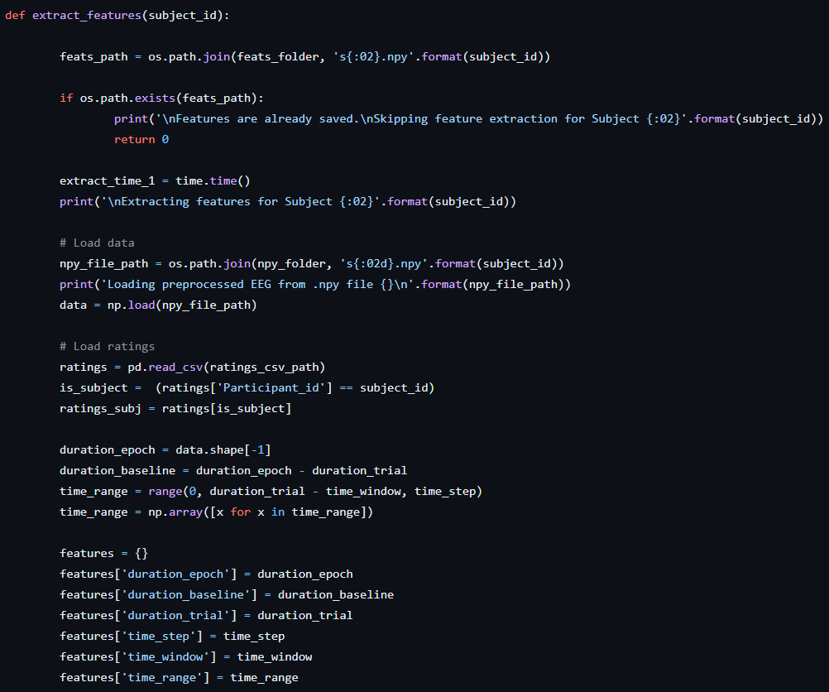 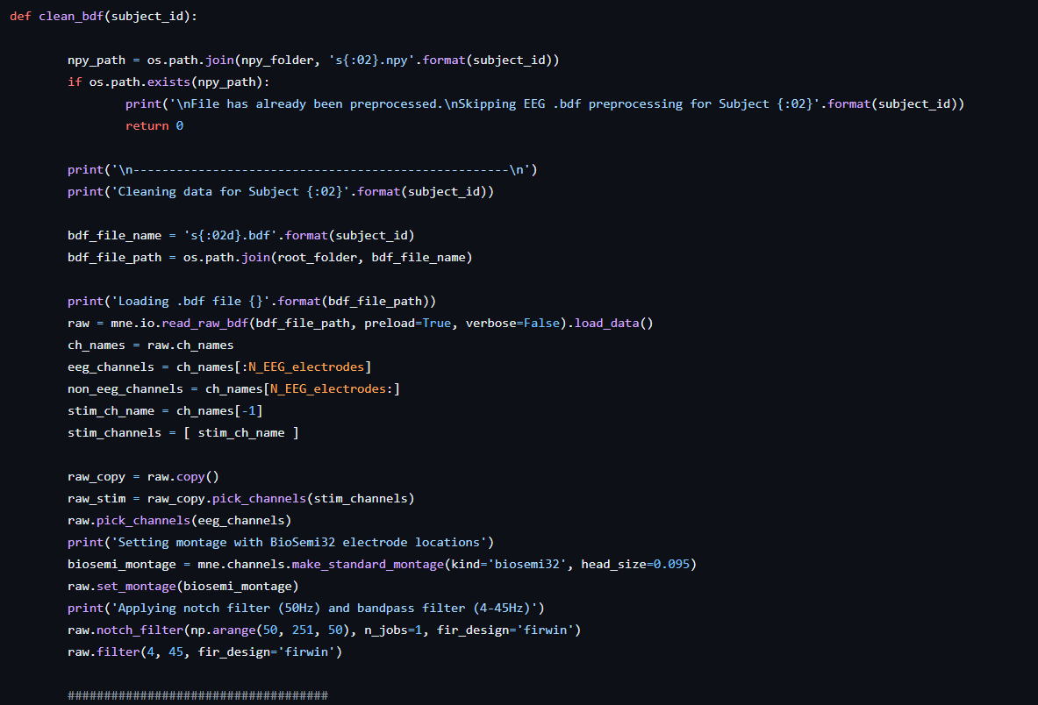

Figure 3. code snippet for getting electrodes info.

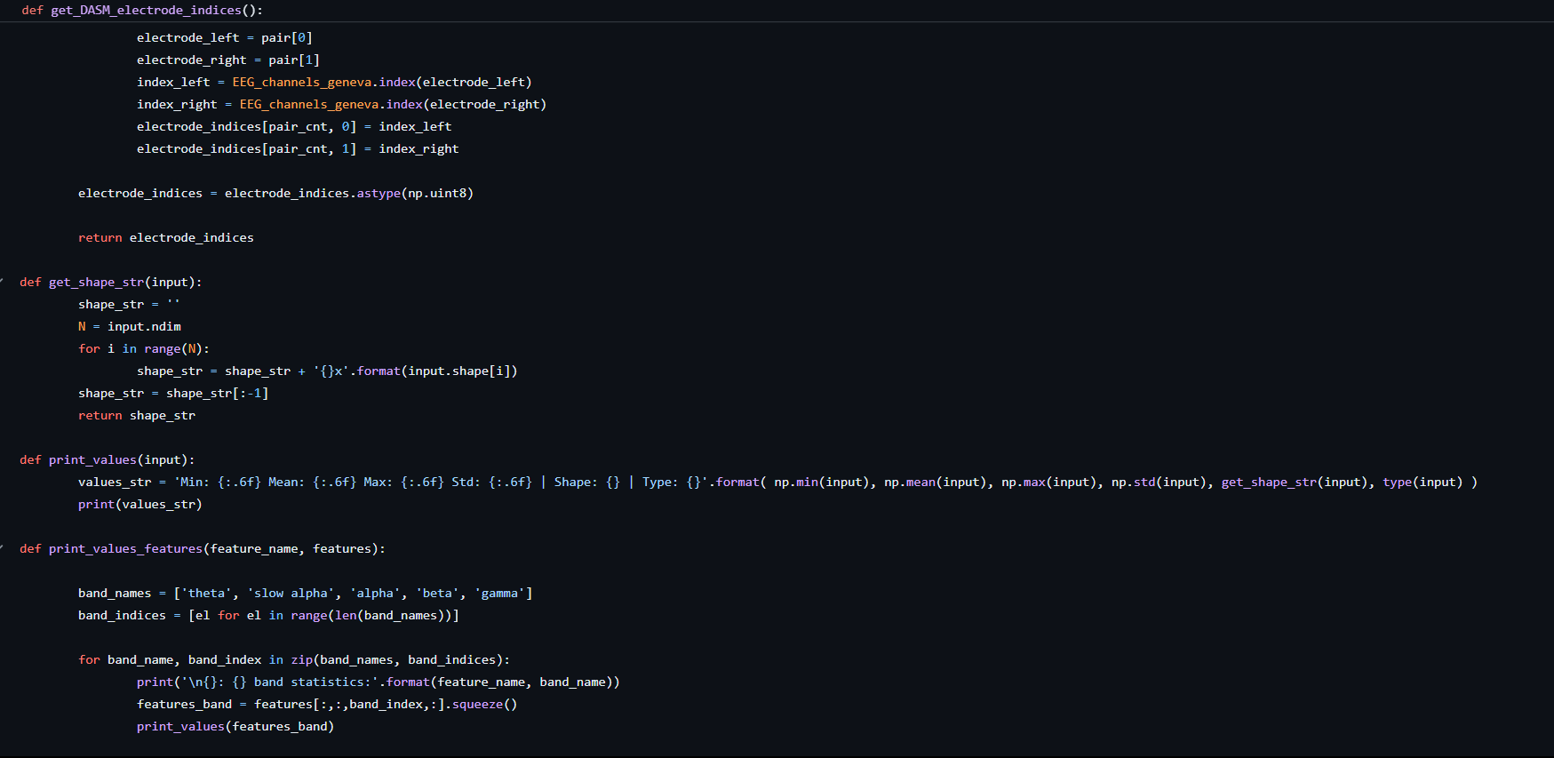

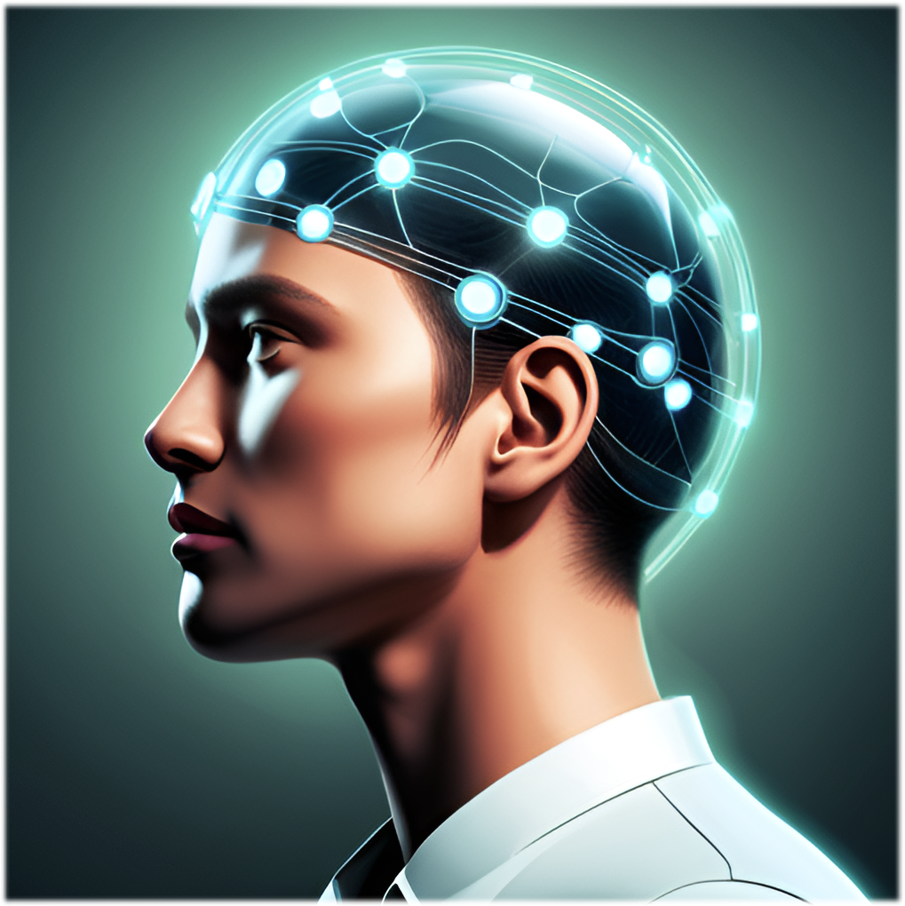 Image

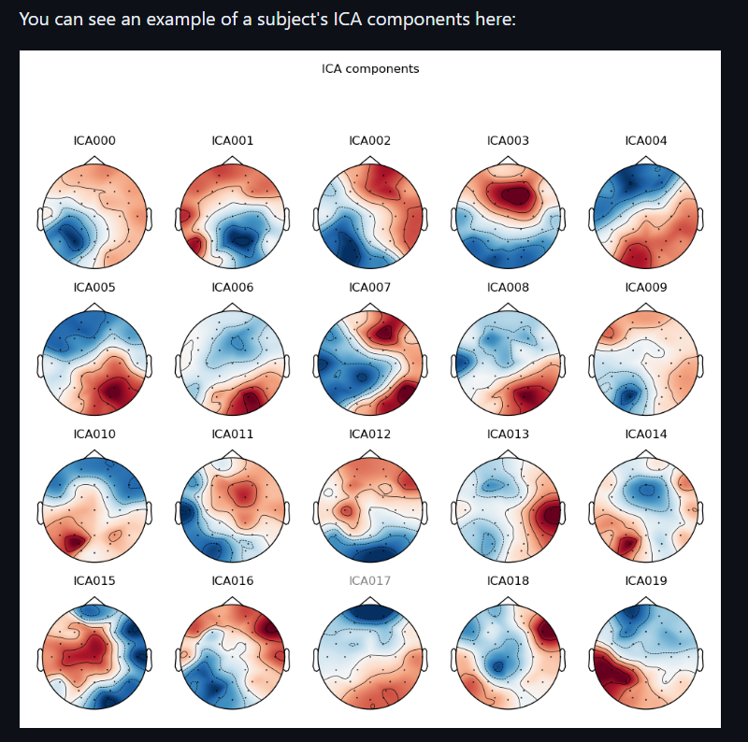

DOWNSAMPLED FEATURES :

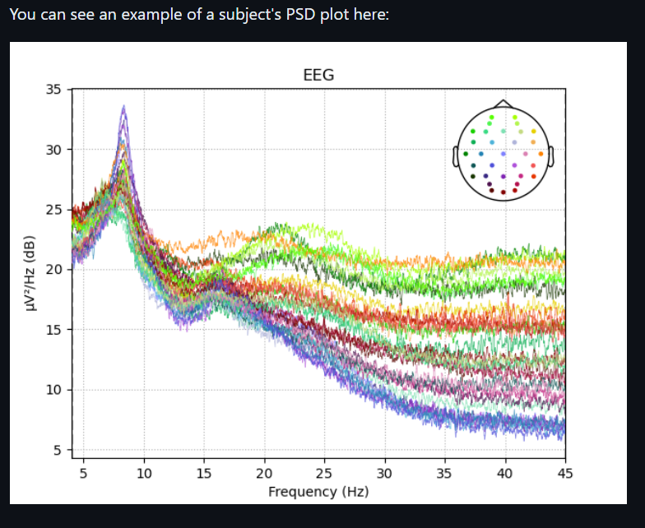

* COMPARISON WITH OTHER MODELS:

In comparing our proposed methodology with alternative models, the utilization of Long Short-Term Memory (LSTM) networks distinguishes our approach by effectively capturing temporal dependencies within Power Spectral Density (PSD) features. The incorporation of MNE (MNE-Python) enhances our model's interpretability through comprehensive EEG data exploration. In contrast, Support Vector Machines (SVM) and k-Nearest Neighbors (KNN) models may exhibit varying performance in capturing temporal nuances. While SVM excels in defining decision boundaries, KNN relies on proximity-based classification. The comparative analysis aims to discern the strengths and limitations of each model, offering insights into the effectiveness of our LSTM-based methodology in emotion recognition.

1. **FUTURE SCOPE:**

1.Enabling Emotional Understanding in Technology: -

Facial expression analysis allows machines to discern human emotions from pictures, advancing technology's capacity to understand people's feelings.

2 Enhancing Human-Computer Interaction: -

Envision a future where computers and games respond to users' emotions, creating a more natural and enjoyable interaction experience.

1. Early Detection for Emotional Health: -

Utilizing technology to identify early signs of stress or low mood could revolutionize mental health care, allowing for timely support and intervention.

1. Optimizing Ads and Products: -

Companies can leverage emotion recognition technology to gauge customer reactions to ads and products, facilitating the creation of more appealing and customer-friendly offerings.

1. Personalizing Learning Experiences: -

In educational settings, computers could adapt teaching methods based on students' emotions, fostering a more personalized and effective learning environment.

1. Strengthening Security Measures: -

Public security systems could utilize emotion recognition to detect unusual emotional states, contributing to enhanced safety in various public spaces.

1. Fostering Positive Work Environments: -

Implementation of emotion recognition technology in workplaces can aid in understanding employees' emotions, facilitating the creation of positive and supportive work environments.

1. **CONCLUSION**

In concluding this endeavor, our exploration into emotion recognition based on EEG signals using a novel deep learning model marks a significant stride at the intersection of neuroscience and artificial intelligence. The proposed methodology, featuring autoencoders, PSD feature extraction, and LSTM networks, stands as an innovative approach in decoding the intricate neural signatures of human emotions. By decomposing EEG data into key components and capturing temporal dynamics, the model strives for a nuanced understanding of emotional states, fostering advancements in affective computing.

The model's optimization journey, involving meticulous experimentation with various structures and hyperparameters, underlines our commitment to refining its performance. Striking a balance between complexity and generalization capabilities, the optimized model emerges as a robust tool for real-world emotion classification.

Moreover, the utilization of the MNE-Python package adds a valuable dimension to our methodology, enabling a deeper exploration and visualization of EEG data. MNE's contribution empowers researchers to unravel spatiotemporal patterns, enhancing the interpretability of our findings.

As we reflect on the significance of this project, the potential applications are vast, spanning mental health monitoring, human-computer interaction, and beyond. The fusion of neuroscience and deep learning holds promise for a future where machines can comprehend and respond to human emotions with heightened accuracy and sensitivity.

In essence, this project not only contributes to the scientific discourse on emotion recognition but also presents a practical and adaptable framework for future research and application. Through our efforts, we aspire to catalyze advancements that redefine our interaction with technology, ultimately fostering a more empathetic and responsive digital landscape

1. **REFERENCES**

* Research Papers:

1)Picard, R. W. (1997). "Affective Computing." MIT Media Lab Perceptual Computing Section Technical Report No. 321.

2)Koelstra, S., Muhl, C., Soleymani, M., Lee, J. S., Yazdani, A., Ebrahimi, T., & Patras, I. (2012). "DEAP: A Database for Emotion Analysis; Using Physiological Signals." IEEE Transactions on Affective Computing, 3(1), 18-31.

3)Lin, Y. P., Wang, C. H., Jung, T. P., Wu, T. L., Jeng, S. K., & Duann, J. R. (2010). "EEG-based emotion recognition in music listening." IEEE Transactions on Biomedical Engineering, 57(7), 1798-1806.

* Websites and Resources:

1. MNE-Python Documentation - Official documentation for MNE-Python, providing in-depth information and tutorials for EEG data analysis.

<https://mne.tools/stable/index.html>

1. IEEE Xplore - A digital library for IEEE articles, including numerous papers on emotion recognition using EEG signals.
2. ResearchGate - A platform where researchers share their publications. You can find numerous papers related to EEG-based emotion recognition. [www.researchgate.com](http://www.researchgate.com)
3. PubMed - A comprehensive database of biomedical literature, including research articles related to EEG and emotion recognition.

<https://pubmed.ncbi.nlm.nih.gov/?term=eeg+emotion+recognition>

1. DEAP DATASET OFFICIAL PAGE <https://www.eecs.qmul.ac.uk/mmv/datasets/deap/index.html>